Dolphin Dynamics

Generic Accounts Export

Customer Guide

Release Number | R17.6.75
Dolphin Feature ID | 138194
Accompanying Documents | Generic Accounts Export_Export File Guide.xlsx  Sample generic accounts export files – in embedded zip file below:

Document Amendment History
Date | Version | Comment | Author
10Sep20 | V1 | Customer guide published.  Also see version 1 of the accompanying spreadsheet – ‘Generic Accounts Export_Export File Guide’ | Milav Gandhi

Contents
Contents 2
Prerequisites 3
Introduction 3
Terminology, Definitions & Useful Links 5
Configuring the Generic Accounts Export in the BMM 5
1. Summary 5
2. ‘Accounts Export Configuration Fields’ Dialog 6
3. Setting Up Specific Bank Account Codes for Card/Adjustment/Other Customer Receipts & Refunds 9
4. Setting Up Pricing Item or Product Code Specific Sales Income & Cost of Sales Accounts 10
5. VAT Code Configuration 11
Generating The Accounts Export Files 11
The Generic Accounts Export Files 12
6. Sales & Cost of Sales 13
7. Customer Receipt & Refunds 14
8. Vendor Payments & Refunds 15
9. Vendor List 16
Using The Business Importer Online Tool Alongside QBO/Xero 16
Using the Generic Accounts Export with QuickBooks Online 17
10. BMM VAT Configuration 17
11. QBO Classes & BMM Accounts Export Branch 18
12. QuickBooks Online Configuration 18
13. Setting up the Business Importer Online Tool for QBO 18
14. QBO Import - Summary Steps 22
15. Other Information 22
Using the Generic Accounts Export with Xero 22
16. BMM VAT Configuration 22
17. Xero Tracking Categories & BMM Accounts Export Branch 23
18. Xero Configuration 23
19. Setting up the Business Importer Online Tool for Xero 24
20. Xero Import - Summary Steps 28
21. Other Information 28
Using the Generic Accounts Export Files with Other Accounts Packages 28
Appendix 29
22. Sample Export Files 29

Prerequisites
The aim of this guide is to support Dolphin customers who wish to use the Generic Accounts Export functionality. This functionality works in conjunction with the Enhanced Dolphin Accounting Methodology (EDAM) processes & the Accounts Export functionality. By following the EDAM processes travel folder accounting figures can be tracked & reported on in Dolphin, which can then be exported out to specific accounts packages.
Before you read this guide & start using this functionality it is strongly recommended that you familiarise yourself with the EDAM processes & Accounts Export functionality – links to user guides for both areas can be found below. This will allow you to understand this guide better, so that you can successfully introduce this module into your existing accounting processes.
Dolphin Dynamics Help Centre links - Enhanced Dolphin Accounting Methodology guide, Accounts Export guide

Introduction
The Booking Management Module’s (BMM) Accounts Export feature previously supported the following accounts packages as standard:
Dolphin Term for Accounts Package | Accounts Package
QuickBooks | QuickBooks Desktop (version 2008 onwards)
Sage Line 50 2013 | Sage 50 (version 2013 onwards)
MYOB | MYOB - Mind Your Own Business

NOTE: Other formats are available in the BMM - e.g. CODA, Navision, Sage Line 50 Invoices & Credit Notes. However, these are custom formats created for specific customers, & are therefore not for general customer use.
To assist our customers who use other accounts packages Dolphin Dynamics have now developed a Generic Accounts Export format. As the name suggests the key aim of this format is to provide a generic set of files which contain information on the three transaction types/areas listed below. These are central to Dolphin’s Enhanced Dolphin Accounting Methodology:
- Sales & Cost of Sales
- Customer Receipts & Refunds
- Vendor Payments & Refunds
The Generic Accounts Export format outputs three files – one per transaction type. Different accounts packages work in different ways, so the aim is to provide as much information as possible for each transaction type. Customers can then pick & choose which columns they use depending on the accounts package they are importing the files into.
NOTE: A 4th Vendor List file is automatically generated alongside the Vendor Payments & Refunds file. This contains information from the BMM vendor profiles, for the financial vendors that appear in the Vendor Payments & Refunds export file.
The diagram below illustrates how the Generic Accounts Export files can be used in conjunction with different accounts packages:

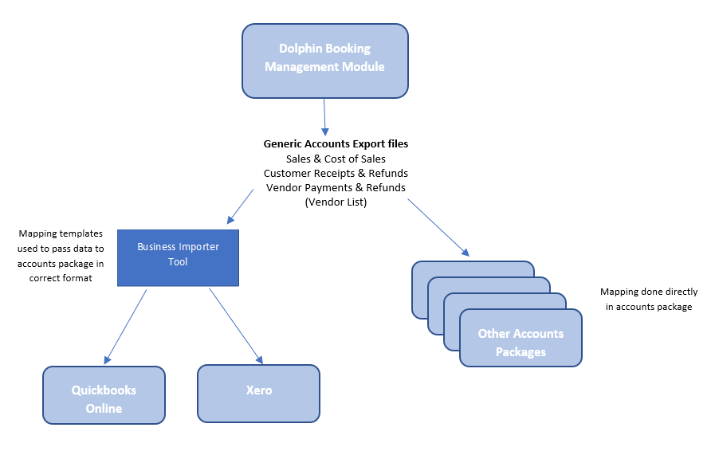
The files can be imported into QuickBooks Online or Xero via the Business Importer Online tool. This tool takes the file data outputted by the BMM and reformats/restructures it so that it can then be imported into QuickBooks Online or Xero. Later sections of this guide cover this area in more detail.
IMPORTANT: Due to limitations in Xero’s API the Generic Accounts Export cannot support the transfer of foreign currency customer payments/refunds AND vendor payments/refunds from the BMM to Xero. Only branch currency customer & vendor payments/refunds are supported for Xero.
Alternatively, customers can take the Generic Accounts Export files & import them directly into other accounts packages. Careful attention must be paid to the different columns in each file & the way in which data is populated in those columns to ensure the correct data is being mapped to their preferred accounts package. It is recommended that each transaction type is carefully tested with sample files to ensure the mapping is correct.
NOTE: The accompanying spreadsheet contains details on each export file’s columns & how these columns are populated - Generic Accounts Export_Export File Guide.xlsx
This guide covers the following areas:
- Configuring the Generic Accounts Export in the BMM
- Generating the Generic Accounts Export files
- An overview of the Generic Accounts Export files
- Using the CloudBusiness’ ‘Business Importer Online’ tool
- Using the Generic Accounts Export feature in conjunction with QuickBooks Online
- Using the Generic Accounts Export feature in conjunction with Xero
PLEASE NOTE: As mentioned above this guide is not a training guide on the Accounts Export module. An Accounts Export Guide can be downloaded from the Dolphin Dynamics Help Centre.

Terminology, Definitions & Useful Links
The table below contains the definitions of terms and abbreviations used throughout the document.
Term / Abbreviation | Definition & Useful Links
BMM | Booking Management Module
EDAM | Enhanced Dolphin Accounting Methodology
QuickBooks Online | Accounts package - referred to as QBO from herein.  https://QuickBooks.intuit.com/login/
Xero | Accounts package  https://login.xero.com/
Business Importer Online Tool & CloudBusiness | CloudBusiness offer a variety of automation tools for bookkeeping & accountants.  https://cloudbusinessllc.com/  Their Business Importer Online Tool allows financial transactions to be electronically imported into QuickBooks Online, Xero, Sage or MYOB.  Dolphin does not support a dedicated accounts export file format for QuickBooks Online & Xero. Instead customers can use the Generic Accounts Export file format in conjunction with the Business Importer Online Tool to import the files into QBO or Xero.  https://b-importer.com/
Account Code | General term used for the accounts package’s ‘mapped account name/number’ that is configured in the BMM.

Configuring the Generic Accounts Export in the BMM
The configuration for the Generic Accounts Export format allows for increased flexibility in terms of being able to configure more granular mapped account codes for different variables – e.g. different bank accounts for GBP vs. EUR cash customer payments, or a Sales Ledger account per folder branch.

Summary
The configuration of the Generic Accounts Export format falls across a number of areas within the BMM:
- The main configuration sits in the Accounts Export Configuration Fields dialog.
NOTE: This includes the flexibility to configure specific Bank Accounts for different credit/debit card types, adjustment reason codes & other payment reason codes.

- For Sales Income & Cost of Sales journals it is possible to group journals by Accounts Export Branch code.

- For the Sales Income & Cost of Sales accounts it is possible to configure:
  - Pricing Item specific accounts
  - Product Code specific accounts
NOTE: Posting sales & cost of sales figures to different accounts based on the BMM pricing item or product code is not a commonly used workflow. Please consider carefully whether you wish to do this as the workflow requires careful configuration & ongoing maintenance as and when new pricing items/product codes are created.

- VAT Code configuration
These areas are explained in detail in the following sections.

‘Accounts Export Configuration Fields’ Dialog
- The main configuration area is under Options > Accounts Export Configuration > Accounts Export Configuration Fields dialog > select Generic Accounts Export from the Accounts Package dropdown:

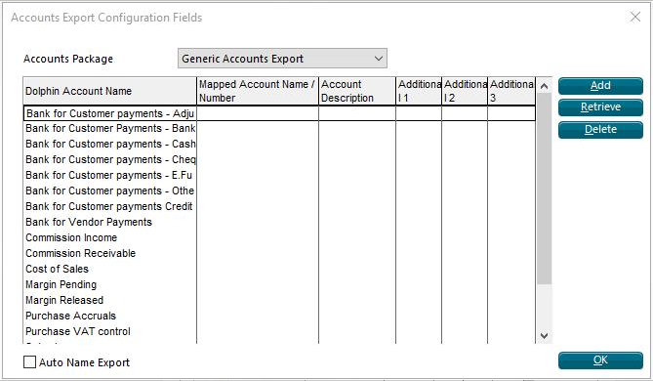

- When configuring the Generic Accounts Export accounts package it is important to tick the Auto Name Export checkbox AND enter csv into the File Extension field:

This configuration will be saved once set, so it only needs to be done once.

- The following default Dolphin Account Name rows will be present in the grid, with fields to enter the Mapped Account Name/Number & an optional Account Description per row:
- Bank for Customer payments – Adjustment
- Bank for Customer payments – Bank draft
- Bank for Customer payments – Cash
- Bank for Customer payments – Cheque
- Bank for Customer payments – Credit cards
- Bank for Customer payments – E. Fund Transfer
- Bank for Customer payments – Other
- Bank for Vendor Payments
- Commission Income
- Commission Receivable
- Cost of Sales
- Margin Pending
- Margin Released
- Purchase Accruals
- Purchase VAT control
- Sales Income
- Sales Ledger
- Sales VAT control
- Split Commission

- By default, there will be 1 row per Dolphin account name when Generic Accounts Export is first selected as the accounts package. However additional rows can be manually added for the account names that support multiple mapped accounts to be configured for different variables. This is explained further in the points below.
NOTE: The ability to add new rows is dependent on the Reference Data security profile setting being ticked (in the Access/Updates tab > Data section).

- Each row contains Additional 1, Additional 2 & Additional 3 columns/fields. These can be used to configure the variables. An example of a variable is the customer currency for a cash customer receipt. Or the folder branch code for a vendor payment.

- Which of the Additional 1/2/3 fields is enabled/disabled will depend on the account name – some account names have all three fields disabled, some all enabled, & some a mixture.

- Additional rows can be added for the account names that allow at least one variable, which in turn means that at least one of the Additional 1/2/3 fields will be enabled.

- The Additional 1 & Additional 2 dropdowns contain lists of codes (e.g. card codes, payment reason codes, currency codes). All codes – active & deleted – will be included in the list as financial data relating to deleted codes still needs to be included in the export files.

- The table below contains the following information:
  - Which account names allow multiple rows
  - Which of the Additional 1/2/3 fields will be enabled/disabled for each account name
  - The variables available for each account name
  - Any mandatory variables
Dolphin Account Name | Multiple rows allowed? | Additional 1 | Additional 2 | Additional 3
Bank for Customer Payments - Adjustment | Yes | Adjustment receipt/refund reason code | Transaction customer currency code | Banking branch code
Bank for Customer Payments – Bank Draft | Yes | N/A – field disabled | Transaction customer currency code | Banking branch code
Bank for Customer Payments – Cash | Yes | N/A – field disabled | Transaction customer currency code | Banking branch code
Bank for Customer Payments – Cheque | Yes | N/A – field disabled | Transaction customer currency code | Banking branch code
Bank for Customer Payments – Credit Cards | Yes | Card code  Mandatory | Transaction customer currency code | Banking branch code
Bank for Customer Payments – E.Fund Transfer | Yes | N/A – field disabled | Transaction customer currency code | Banking branch code
Bank for Customer Payments – Other | Yes | Other receipt/refund reason code | Transaction customer currency code | Banking branch code
Bank for Vendor Payments | Yes | N/A – field disabled | Transaction vendor currency code  Mandatory | Folder branch code
Commission Income | No | N/A – field disabled | N/A – field disabled | N/A – field disabled
Commission Receivable | Yes | N/A – field disabled | N/A – field disabled | Folder branch code
Cost of Sales | No | N/A – field disabled | N/A – field disabled | N/A – field disabled
Margin Pending | Yes | N/A – field disabled | N/A – field disabled | Folder branch code
Margin Released | Yes | N/A – field disabled | N/A – field disabled | Folder branch code
Purchase Accruals | Yes | N/A – field disabled | N/A – field disabled | Folder branch code
Purchase VAT Control | Yes | N/A – field disabled | N/A – field disabled | Folder branch code
Sales Income | No | N/A – field disabled | N/A – field disabled | N/A – field disabled
Sales ledger | Yes | N/A – field disabled | N/A – field disabled | Folder branch code
Sales VAT Control | Yes | N/A – field disabled | N/A – field disabled | Folder branch code
Split commission | No | N/A – field disabled | N/A – field disabled | N/A – field disabled

Taking the account name Bank for Customer Payments – Adjustment as an example, this account name supports multiple rows with 3 variables - Adjustment receipt/refund reason code, Transaction customer currency code, Banking branch code. This means it is possible to configure a different bank account code for every single combination of these 3 variables, if required!

For example with the following configuration…
- 2 adjustment receipt/refund reason codes - XXX, YYY
- 2 transaction customer currency codes – GBP, EUR
- 2 banking branch codes – HQ, XX
….it would be possible to configure up to 8 mapped account codes for the various combinations of the three variables:
Mappings for ‘Bank for Customer Payments – Adjustment’ | Adjustment receipt/refund reason code | Transaction customer currency code | Banking branch code
1 | XXX | GBP | HQ
2 | XXX | GBP | XX
3 | XXX | EUR | HQ
4 | XXX | EUR | XX
5 | YYY | GBP | HQ
6 | YYY | GBP | XX
7 | YYY | EUR | HQ
8 | YYY | EUR | XX

Equally it is also possible to configure just one mapped account code for account name Bank for Customer Payments – Adjustment, with no variables set. This would be the correct configuration if all adjustment receipts/refunds should be exported to one bank account.

- The Additional 2 dropdown for ALL Bank for Customer Payment rows will be blank by default & does not need to be populated, unless you process customer payments in different currencies and have the Multi Currency Sales module switched on in the BMM so that you can issue customer receipts & refunds in currencies different to the BMM branch currency.
In this case you will need to flag the relevant currency codes as a Customer Currency:

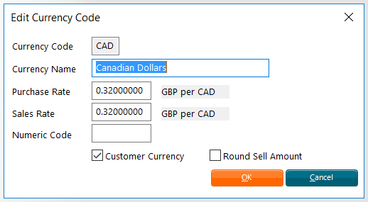

The Additional 2 dropdown will then list these customer currency codes, thereby allowing different bank accounts to be mapped for the various currencies that customer payments are processed in.

- The Additional 1 dropdown for Bank for Customer Payments – Credit cards rows will display all card codes loaded in the BMM.
- If customer payments & refunds are processed by credit or debit card then one Bank for Customer Payments – Credit cards row must be configured per card code, as Additional 1 is mandatory for this row type.
- If all card transactions are processed through the same bank account each row can contain the same mapped account code.

- The Additional 2 dropdown for ALL Bank for Vendor Payment rows will display all currency codes loaded in the BMM.
One Bank for Vendor Payment row must be configured per currency that vendors are paid in, as the Additional 2 field is mandatory for this row type. For example:
- If vendors are paid in GBP only then one Bank for Vendor Payment row should be configured with Additional 2 set to GBP.
- If vendors are paid in GBP & EUR then two Bank for Vendor Payment rows should be configured with Additional 2 set to GBP & EUR respectively.

- A uniqueness check takes place when adding new/editing existing rows. This is to ensure that no two rows exist with the same combination of values in the Additional 1/2/3 fields, as this would mean that multiple mapped accounts exist for the same underlying data:
- The check takes place when a row is retrieved & then saved.
- If another row already exists with the same values in the Additional 1/2/3 fields the following warning is displayed:
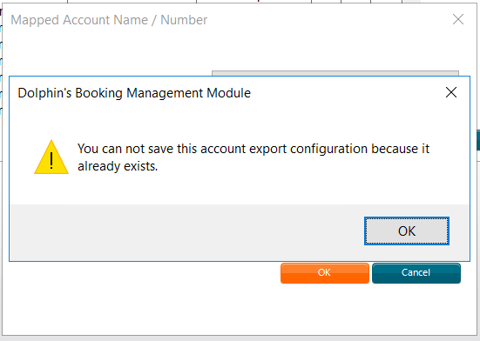

This will ensure that duplicate configuration is not allowed.

Setting Up Specific Bank Account Codes for Card/Adjustment/Other Customer Receipts & Refunds
For Customer Receipts & Refunds it is possible to configure specific bank accounts for different Card codes, Adjustment reason codes & Other payment reason codes.
This can be done via the main Accounts Export Configuration Fields dialog:
- The Additional 1 field for Bank for Customer Payments – Credit cards rows will contain all card codes
- The Additional 1 field for Bank for Customer Payments – Other rows will contain all adjustment receipt/refund reason codes
- The Additional 1 field for Bank for Customer Payments – Adjustment rows will contain all other receipt/refund reason codes
NOTE: Active & deleted codes will appear in the Additional 1 field dropdown lists.
The codes will be selectable from the Additional 1 dropdown for these Bank for Customer Payments rows – e.g.
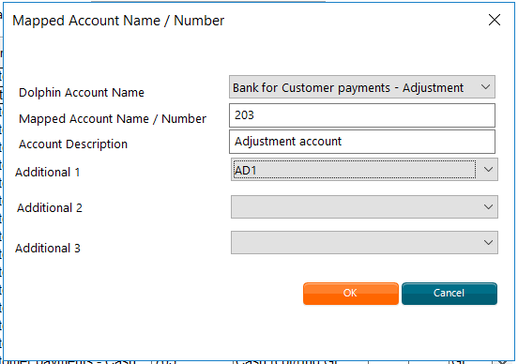
NOTE: The BMM also allows specific mapped accounts to be configured against the actual card type codes, adjustment reason codes & other payment reason codes. This is done via the Search menu under Financial Reference Data > Credit Cards > Card Types OR Reason Codes > Adjustment Receipt/Refunds OR Other Receipt/Refunds. The Generic Accounts Export does not make use of this configuration.

Setting Up Pricing Item or Product Code Specific Sales Income & Cost of Sales Accounts
The Generic Accounts Export format will respect pricing item specific & product code specific mapped accounts for the Sales income & Cost of sales accounts:
Search > Financial Reference Data > Pricing Items
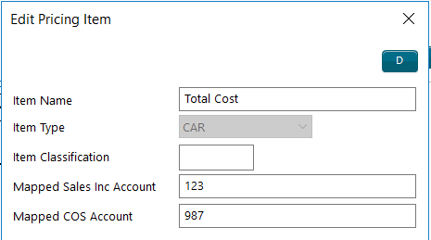
Search > Product Codes
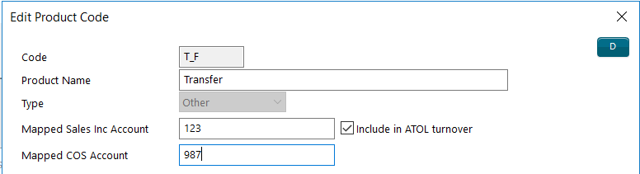
The logic:
- The Pricing Item’s mapped Sales Income &/or Cost of Sale account will be used, if present.
- If no mapped account exists at pricing item level the item Product Code’s mapped Sales Income &/or Cost of Sale account will be used instead, if present.
- Finally, if no mapped Sales Income &/or Cost of Sale account exists at product code level then the mapped Sales Income & Cost of Sale accounts configured in the main Accounts Export Configuration Fields dialog will be used.
As a rule, any account mappings in the underlying reference data will be ignored where the BMM supports account mapping within the Accounts Export Configuration dialog.

VAT Code Configuration
The accounting system’s VAT codes must be mapped against the BMM VAT codes using the following fields within the Add/Edit VAT Code dialog (accessed via Search > Financial Reference Data > VAT Codes):
- Mapped Sales/Comm VAT Acc Code – this is used for the Sales & Commission VAT types
- Mapped Purchase/Split Comm VAT Acc Code – this is used for the Purchase & Split Commission VAT types
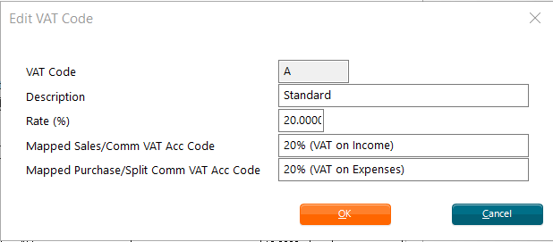
NOTE: Most accounting systems will use the same VAT code regardless of the VAT type, in which case the same VAT code should be configured in both fields.
See sections below for further guidance on setting up VAT codes if using QBO or Xero.

Generating The Accounts Export Files

IMPORTANT: Before running the Generic Accounts Export for the first time please go to Options > Accounts Export Configuration > select Generic Accounts Export > make sure the Auto Name Export checkbox is ticked AND csv is entered in the File Extension field:
This configuration will be saved once completed & therefore only needs to be done once.

NOTE: If you are not familiar with the Accounts Export functionality please refer to the manual which provides a more complete explanation of this functionality.

- Select Search > Export > Accounts Export:
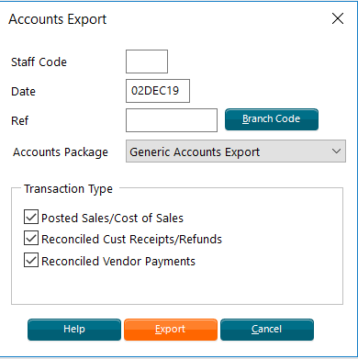
- Optional – set Staff Code & Branch Code filters if required.
- Set the Date.
- Enter the accounts export reference in the Ref field.
IMPORTANT: Commas should not be included in the Ref field. Entering a comma will result in the export file columns being incorrect. The BMM automatically removes commas from other values included in the export file such as customer/vendor payment reconciliation reference, vendor names, customer names, etc. However, it is not possible to remove them from the accounts export reference.

- All the Transaction Type checkboxes will be selected by default:

  - Post Sales & Cost of Sales checkbox > generates the Sales & Cost of Sales export file (filename SALESCOS)
  - Reconciled Cust Receipts/Refunds checkbox > generates the Customer Receipts & Refunds export file (filename RECREF)
  - Reconciled Vendor Payments checkbox > generates the Vendor Payments & Refunds export file (filename VENPAY) & Vendor List export file (filename VENLST)

Update the selection if you do not want to export all the file types.

NOTE: The top three export files contain financial data. The 4th file contains vendor profile information only. This file is not used by QBO or Xero.

- Select Export & follow the normal accounts export workflow steps to generate the export files & save them to a file location.

The Generic Accounts Export Files
- The export files are comma separated files - .csv
- Filename format - DOLPHIN_FileType_XXX_DDMMYYHHMM.csv

Where:
DOLPHIN = Standard prefix
FileType = SALESCOS - Sales & Cost of Sales, RECREF - Customer Receipts & Refunds, VENPAY - Vendor Payments & Refunds, VENLST – Vendor List
XXX = BMM Accounts Export Staff Code
DDMMYYHHMM = export file creation date/time stamp

- Commas are automatically removed from all the data when generating the export files. The only exception is the Accounts Export Reference which is manually entered in the Accounts Export dialog. More details can be found in the section above.
- The Vendor List export file is automatically generated alongside the Vendor Payments export file. This will contain key information from the vendor profiles of the financial vendors present in the Vendor Payments file.
NOTE 1: See the Generic Accounts Export_Export File Guide spreadsheet for detailed information on each export file’s contents.
NOTE 2: Also accompanying this guide is a batch of sample generic accounts export files for different booking scenarios. Refer to the Sample Export Files section in the Appendix for the list of booking scenarios & corresponding export file names. The actual files can be found in the embedded zip file on the front page of this guide.

Sales & Cost of Sales
When generating the Sales & Cost of Sales export file the following logic will be used:
- Financial transactions that meet the following criteria will be included in the export file:
  - The transaction is one of the following types, AND
Invoice (I), Credit Note (C), Cash Sale (S), Accrual Adjustment (A), Commission Only (M)
  - The transaction has been flagged as ‘accounts posted’, AND
  - The transaction’s accounts posting date is on or before the Account Export dialog’s Date value, AND
  - The transaction has not been flagged as ‘accounts exported’
- The Sales & Cost of Sales export file will contain amounts in branch currency only.
- Each accounting journal will be represented by multiple rows within the export file – i.e. the file will contain a balanced multi-line output for each journal entry.
- Each row will represent a debit or credit to one of the following accounts: Sales ledger, Sales income, Purchase Accruals, Cost of Sales, Split commission, Commission income, Commission receivable, Margin Pending & Margin Released.
- For each row the BMM will look for the appropriate mapped accounts in the BMM:
- Sales income & Cost of sales accounts:

Step 1 | Use transaction Pricing Item’s mapped sales income &/or cost of sales account code if present
Step 2 | Use transaction item Product Code’s mapped sales income &/or cost of sales account code if present
Step 3 | Use mapped account code from main Accounts Export Configuration Fields dialog – Sales Income & Cost of Sales rows.

- Sales ledger, Purchase Accruals, Commission receivable, Margin Pending & Margin Released accounts – look for matching row in main Accounts Export Configuration Fields dialog as follows:
NOTE: The Additional 1 & 2 fields for the above Dolphin account names are disabled.

Step 1 | Match on Additional 3 - the transaction’s folder branch code
Step 2 | Find catch-all row where Additional 3 is blank

- Split commission & Commission income accounts – look for matching row in main Accounts Export Configuration Fields dialog as only one mapped account can be configured for these account types.

Customer Receipt & Refunds
When generating the Customer Receipts & Refunds export file the following logic will be used when generating the file:
- Customer transactions - i.e. Receipts (R) & Refunds (F) - that meet the following criteria will be included in the export file:
  - The customer transaction has been reconciled, AND
  - The transaction’s customer payment reconciliation date is on or before the Account Export dialog’s Date value, AND
  - The transaction has not been flagged as ‘accounts exported’

- For each customer transaction, the BMM will look for the appropriate Bank for Customer Payment & Sales Ledger mapped accounts within the Generic Accounts Export accounts package configuration rows, based on the transaction’s attributes.

- To find a matching Bank for Customer Payments account:
  - The BMM will first look for Bank for Customer Payments rows for the transaction’s payment method – Adjustment, Bank draft, Cash, Cheque, Card, E-fund transfer or Other.
  - Within this subset of rows, the BMM will then look for a matching row as follows:
NOTE: The Additional fields for Bank for Customer Payments rows are used for:
    - Additional 1 – Adjustment receipt/refund reason code, Other receipt/refund reason code or Card code.
    - Additional 2 - Transaction customer currency code
    - Additional 3 - Banking branch code

For payment methods where the Additional 1 field is disabled:
Step 1 | Match on Additional 2 and 3
Step 2 | Match on Additional 2 only, where Additional 3 is blank
Step 3 | Match on Additional 3 only, where Additional 2 is blank
Step 4 | Find catch-all row where Additional 2 and 3 are blank

For payment methods where the Additional 1 field is enabled:
Step 1 | Match on Additional 1 and 2 and 3
Step 2 | Match on Additional 1 and 2, where Additional 3 is blank
Step 3 | Match on Additional 1 and 3, where Additional 2 is blank
Step 4 | Match on Additional 2 and 3, where Additional 1 is blank
Step 5 | Match on Additional 1 only, where both Additional 2 and 3 are blank
Step 6 | Match on Additional 2 only, where both Additional 1 and 3 are blank
Step 7 | Match on Additional 3 only, where both Additional 1 and 2 are blank
Step 8 | Find catch-all row where all 3 Additional fields are blank

- To find a matching Sales Ledger account the BMM will look for matching Sales Ledger rows as follows:
NOTE: The Additional 1 & 2 fields for Sales Ledger rows are disabled.

Step 1 | Match on Additional 3 - the customer transaction’s folder branch code
Step 2 | Find catch-all row where Additional 3 is blank

- ‘Catch-all rows’ with blank Additional fields (where they are optional) should be configured to sweep up any transactions that do not need to be mapped to more granular accounts – for example:
  - A Bank for Customer Payments – Cash row which has all the Additional fields left blank (so it applies to all customer currencies & banking branches)
  - A Sales Ledger row with Additional 3 left blank (so it applies to all folder branch codes)
This will ensure that the export file’s account code/name columns always contain a value. If the BMM cannot find a row which matches the transaction the corresponding export file column(s) will be blank.
- Each individual E-fund transfer, Adjustment & Other customer receipt and refund will be itemised in the export file to aid bank reconciliation in the accounts package.

- Cash, Card, Bank draft & Cheque customer transactions will be grouped based on:
  - Their Bank Account & Sales Ledger account codes
  - Customer payment reconciliation date
  - Accounts export branch (configured under Options > Branch details > Financial 1 > Account Export Branch field)
  - Transaction currency
And a row will be added to the export file per group.

- The Customer Receipts & Refunds export file will contain transaction values in both branch currency & customer currency.

Vendor Payments & Refunds
When generating the Vendor Payments & Refunds export file the following logic will be used when generating the file:
- Vendor transactions (i.e. payments & refunds) that meet the following criteria will be included in the export file:
  - The vendor transaction has been reconciled, AND
  - Its vendor reconciliation date is on or before the Account Export dialog’s Date value, AND
  - The transaction has not been flagged as ‘accounts exported’

- For each transaction, the BMM will look for the appropriate Bank for Vendor Payment & Purchase Accruals mapped accounts within the Generic Accounts Export accounts package configuration rows, based on the transaction’s attributes.

- To find a matching Bank for Vendor Payments account the BMM will look for a Bank for Vendor Payments row as follows:
NOTE: The Additional fields for Bank for Vendor Payments rows are used for:
    - Additional 1 – Disabled.
    - Additional 2 - Transaction vendor currency code
    - Additional 3 – Folder branch code

Step 1 | Match on Additional 2 and 3
Step 2 | Match on Additional 2 only, where Additional 3 is blank
Step 3 | Match on Additional 3 only, where Additional 2 is blank
Step 4 | Find catch-all row where Additional 2 and 3 are blank

- To find a matching Purchase Accruals account the BMM will look for a Purchase Accruals row as follows:
NOTE: The Additional 1 & 2 fields for Purchase Accrual rows are disabled.

Step 1 | Match on Additional 3 - the vendor transaction’s folder branch code
Step 2 | Find catch-all row where Additional 3 is blank

- The vendor payments will be grouped based on:
  - Their Bank Account & Purchase Accrual account codes
  - Vendor payment reconciliation reference
  - Vendor payment reconciliation date
  - Accounts export branch (configured under Options > Branch Details > Financial 1 > Account Export Branch field)
And a row will be added to the export file per group

- The Vendor Payments & Refunds export file will contain transaction values in both branch currency & vendor currency.

Vendor List
The Vendor List export file is automatically generated alongside the Vendor Payments export file. This will contain key information from the vendor profiles of the financial vendors present in the Vendor Payments & Refunds file.
The file does not contain any financial data & is an optional file that may be useful depending on which accounting package the files are being imported into.

Using The Business Importer Online Tool Alongside QBO/Xero
The BMM already supports account exports to Sage & MYOB as standard formats, but not QBO or Xero. If customers wish to use these accounts packages, they will need to use CloudBusiness’ Business Importer Online tool. The tool imports the Generic Accounts Export files generated by the BMM and pushes the file data straight through to QBO/Xero.
NOTE: The Business Importer Tool passes the data to QBO/Xero via an API call. It is not possible to generate a file from the Business Importer Tool to manually import into QBO/Xero.
Three mapping templates will need to be created in the tool – one per export file. This is a one-off exercise – once the templates are created, they can be reused for each import into QBO/Xero.
Customers will need to purchase a license for Business Importer. The Terminology, Definitions & Useful Links section contains the relevant website links.

Using the Generic Accounts Export with QuickBooks Online
The Generic Accounts Export files can be imported into QBO using the Business Importer Online tool.
Configuration must be completed in the BMM, QBO & Business Importer. The BMM configuration is detailed in the earlier Configuring the Generic Accounts Export in the BMM section. The sections below will guide you through the remaining areas.

BMM VAT Configuration
VAT Codes
Refer to the QuickBooks Help Page on VAT codes for a list of QBO common VAT codes.
The QBO VAT Codes will need to be mapped to the BMM VAT Codes, via Search > Financial Reference Data > VAT Codes > Add/Edit VAT Code dialog. The QBO VAT code(s) must be entered into the following fields:
- Mapped Sales/Comm VAT Acc Code – this is used for the Sales & Commission VAT types
- Mapped Purchase/Split Comm VAT Acc Code – this is used for the Purchase & Split Commission VAT types
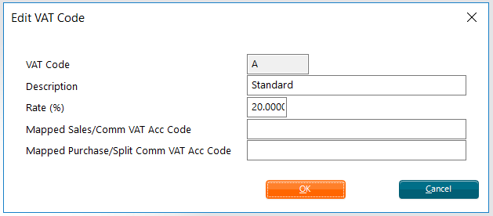
IMPORTANT: Both fields must be filled in. If the accounting system uses the same VAT code regardless of VAT type enter the same code in both fields.
For example, standard rated VAT code in QBO is ‘20.0% S’ – this should be mapped to VAT Code A in the BMM:
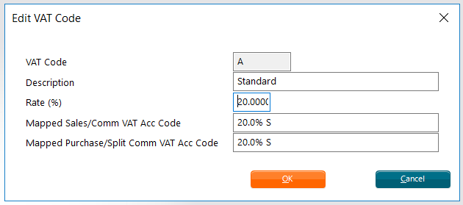

VAT Control Account
QBO has a pre-configured default VAT control account is automatically used during the import by virtue of the QBO VAT codes being mapped to the BMM VAT Codes.
There is therefore no need to configure Purchase VAT Control or Sales VAT Control account numbers in the Accounts Export configuration dialog if using QBO.

QBO Classes & BMM Accounts Export Branch
QBO has a Class tracking feature which allows income, expenses & profitability to be tracked by business segment. If enabled the BMM can be configured to support the passing of this value in the Generic Accounts Export files.

In QBO classes are created & managed via Settings > All Lists > Classes.

In the BMM the required class codes are configured at branch level, via Options > Branch Details > Financial 1 > Account Export Branch field

QuickBooks Online Configuration
The chart of accounts will need to be set up within QBO. The table below summaries the key QBO accounts that the BMM will need to be mapped to, & how those accounts should be configured in QBO:
BMM | QBO Account
Dolphin Account Name | Account Type | Detail Type | Additional Notes
Bank for Customer Payments | Cash at bank and in hand | Current | Currency = currency of bank account
Bank for Vendor Payments | Cash at bank and in hand | Current | Currency = currency of bank account
Commission Income | Income | Sales of Product Income
Commission Receivable | Current assets | Other current assets | Currency = home currency (i.e. BMM branch currency)
Cost of Sales | Cost of sales | Cost of sales | Currency = home currency (i.e. BMM branch currency)
Purchase Accruals | Current Liabilities | Current Liabilities | Currency = home currency (i.e. BMM branch currency)
Purchase VAT Control | - | - | Go to BMM VAT Configuration section.
Sales Income | Income | Sales of Product Income
Sales Ledger | Current asset | Other current assets | Currency = home currency (i.e. BMM branch currency)
Sales VAT Control | - | - | Go to BMM VAT Configuration section.
Split Commission | Cost of Sales | Cost of Sales, or  Other costs of sales - COS

Setting up the Business Importer Online Tool for QBO
Initial Setup in Business Importer
- Log into Business Importer
- Hover over the login email address on the top right & select the Account option
- Go to Companies > Add Company > select QuickBooks to configure the QuickBooks account details. This will connect Business Importer to QBO. Repeat as required to create additional companies.

Initial Setup in QBO
NOTE: This step is required in order to be able to launch Business Importer from within QBO.
- Log into QBO.
- Select Apps from the left-hand navigation pane > Find App > search for ‘Business Importer’
- Click on Get app now to install the Business Importer Online tool.
- The tool will now appear under Apps > My Apps
Creating the Business Importer Mapping Templates
IMPORTANT: You will need a Generic Accounts export file for all three file types in order to create the mapping templates in business importer. Unfortunately it is not possible for Dolphin to provide test files as the content of the files will depend on how the BMM is configured, and some of this configuration will be influenced by the accounts package being used.
- In QBO select Apps > My Apps
- Select Action against the Business Importer app > Launch
- Business Importer Online will be launched in a new browser tab
- Select Upload file
The next steps must be repeated three times, once per Generic Accounts Export file type.
- Select the transaction/list type below depending on which Generic Accounts Export file type’s mapping template is being created:
  - Sales & Cost of Sales file > Journal Entry
  - Customer Receipt & Refunds file > Transfer
  - Vendor Payments & Refunds > Transfer
- Click on Next
- Use the Browse file OR Insert the link option to point Business Importer to the relevant Generic Accounts export file – e.g. Customer Receipts & Refunds file
- The Next button will be enabled – select it to enter the Mapping page
- Make sure the correct company is displayed in the top left field, and the correct transaction/list type in the top right field – e.g. Transfer
- The lower left field will default to Create new mapping. In the lower right field enter a name for the mapping template - e.g. Customer Transactions
- Underneath is the mapping table with a number of columns:
  - Provider labels column - represents the QBO field
  - Your labels column – allows you to map the QBO field to a specific column from the Generic Accounts Export file. The dropdown will display the file column, with mapped columns appearing in green
  - Default value column – to be used to map a default value to a QBO field, rather than a value from the Generic Accounts Export file
- The screenshots below illustrate the required mapping for each export file type.
  - It is very important to follow these screenshots to ensure the data is imported into QBO correctly. Deviating from this mapping could result in unexpected/incorrect QBO entries.
  - Not all QBO fields will be mapped to an export file column. Equally not all export file columns will be mapped to a QBO field.

Mapping for Sales & Cost of Sales file

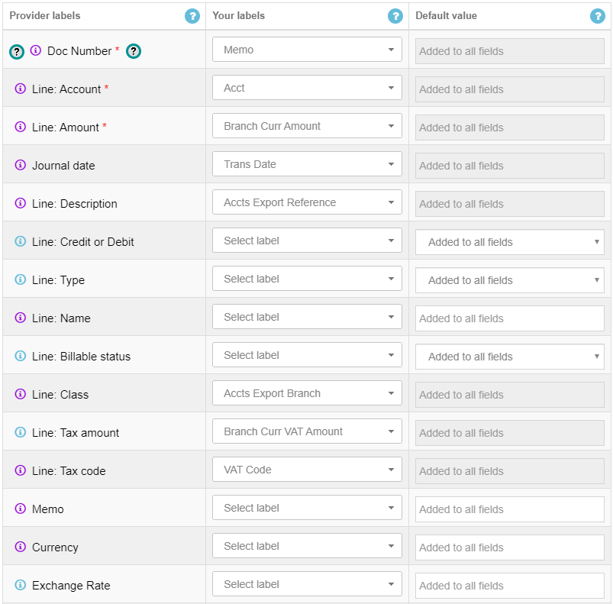
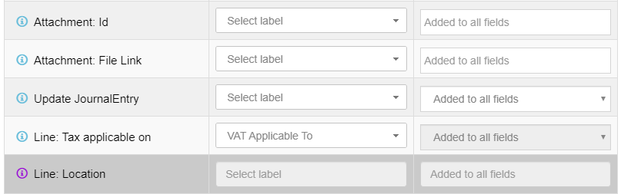

Mapping for Customer Receipts & Refunds file
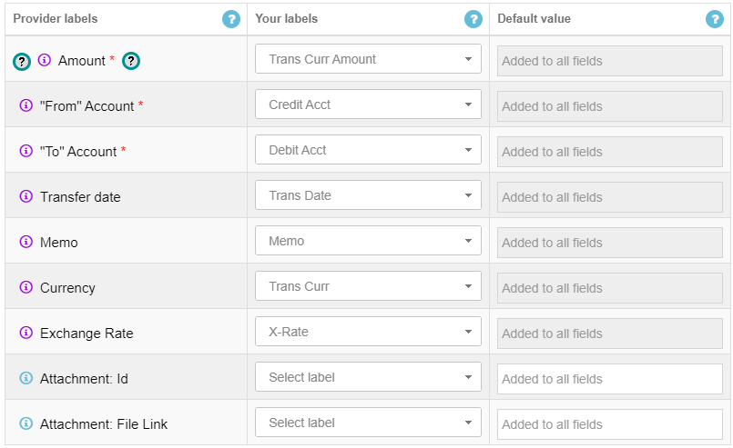

Mapping for Vendor Payments & Refunds file

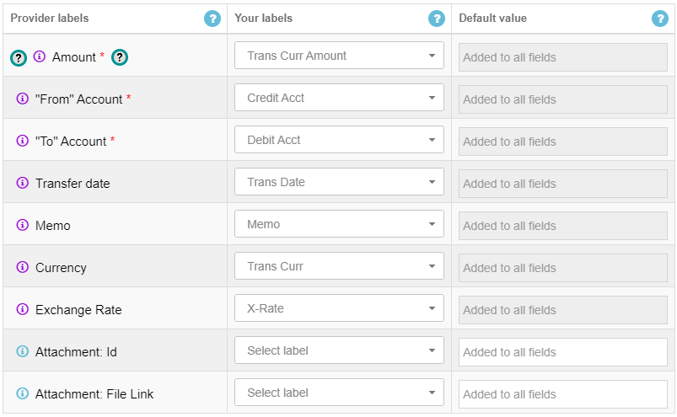

- Clicking on Next or Start Import will save the mapping template.
- Saved templates will then appear in the lower left dropdown menu:
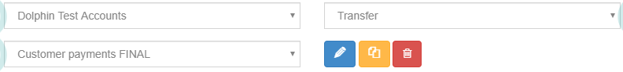

The configuration to import the Generic Accounts Export files from the BMM into QBO via Business Importer should now be complete! Going forwards refer to the section below for the summary steps to import your Generic Accounts Export files into QBO.

QBO Import - Summary Steps
- Log into QBO
- Go to Apps > My Apps
- Locate Business Importer & launch it
- Select Upload file
- Select the transaction/list type depending on which Generic Accounts Export file type you wish to import:
  - Sales & Cost of Sales file > Journal Entry
  - Customer Receipt & Refunds file > Transfer
  - Vendor Payments & Refunds > Transfer
- Point Business Importer to the relevant Generic Accounts export file
- On the Mapping page select your pre-configured mapping template
- Run the import
- The data will now be in QBO

Other Information
- Business Importer has a ‘Revert’ feature when importing into QBO. This allows you to review the imported data in QBO before saving it. If there are any issues the Revert option deletes the imported data.
NOTE: This is not supported for Xero imports.
- The Vendor List file is not required for the QBO import.

Using the Generic Accounts Export with Xero
The Generic Accounts Export files can be imported into Xero using the Business Importer Online tool.
Configuration must be completed in the BMM, Xero & Business Importer. The BMM configuration is detailed in the earlier Configuring the Generic Accounts Export in the BMM section. The sections below will guide you through the remaining areas.
IMPORTANT: Due to limitations in Xero’s API the Generic Accounts Export cannot support the transfer of foreign currency customer payments/refunds AND vendor payments/refunds from the BMM to Xero. Only branch currency customer & vendor payments/refunds are supported for Xero.

BMM VAT Configuration
VAT Codes
Refer to the Xero Help Page on Tax Rates for a list of Xero tax rates (i.e. VAT codes).
The Xero VAT Codes will need to be mapped to the BMM VAT Codes, via Search > Financial Reference Data > VAT Codes > Add/Edit VAT Code dialog. The Xero VAT code(s) must be entered into the following fields:
- Mapped Sales/Comm VAT Acc Code – this is used for the Sales & Commission VAT types
- Mapped Purchase/Split Comm VAT Acc Code – this is used for the Purchase & Split Commission VAT types
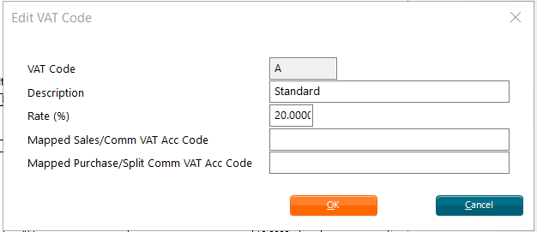
For example, the standard rated VAT code for Xero is ‘20% (VAT on Expenses)’ or ‘20% (VAT on Income)’. In the BMM this should be mapped as follows to VAT Code A:

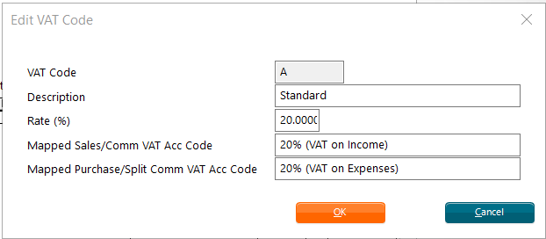

VAT Control Account
Xero has a pre-configured default VAT account - account code 820 - which is automatically used during the import by virtue of the QBO Xero tax rates being mapped to the BMM VAT Codes.
There is therefore no need to configure Purchase VAT Control or Sales VAT Control account numbers in the Accounts Export configuration dialog if using Xero.

Xero Tracking Categories & BMM Accounts Export Branch
Xero has a Tracking Category feature which allows transactions to be categorised for reporting purposes. If enabled the BMM can be configured to support the passing of this value in the Generic Accounts Export files.

In Xero tracking categories are created & managed via Accounting > Advanced > Tracking Categories.

In the BMM the required class codes are configured at branch level, via Options > Branch Details > Financial 1 > Account Export Branch field.

Xero Configuration
The chart of accounts will need to be set up within Xero. The table below summaries the key Xero accounts that the BMM will need to be mapped to, & how those accounts should be configured in Xero:
BMM Dolphin Account Name | Xero – Account Type | Xero – Account Category | Xero - Additional Notes
Bank for Customer Payments | Bank Account | - | Currency = currency of bank account
Bank for Vendor Payments | Bank Account | - | Currency = currency of bank account
Commission Income | Other Income | Revenue | Default tax setting = No VAT
Commission Receivable | Current Asset | Assets | Default tax setting = No VAT
Cost of Sales | Direct Costs | Expenses | Default tax setting = No VAT
Purchase Accruals | Current Liability | Liabilities | Default tax setting = No VAT
Purchase VAT Control | - |  | Go to BMM VAT Configuration section
Sales Income | Revenue | Revenue | Default tax setting = No VAT
Sales Ledger | Current Asset | Asset | Default tax setting = No VAT
Sales VAT Control | - |  | Go to BMM VAT Configuration section
Split Commission | Direct Cost | Expenses | Default tax setting = No VAT

Setting up the Business Importer Online Tool for Xero
Initial Setup in Business Importer
- Log into Business Importer
- Hover over the login email address on the top right & select the Account option
- Go to Companies > Add Company > select Xero to configure the Xero account details. This will connect Business Importer to Xero. Repeat as required to create additional companies.
Creating the Business Importer Mapping Templates
IMPORTANT: You will need a Generic Accounts export file for all three file types in order to create the mapping templates in business importer. Unfortunately it is not possible for Dolphin to provide test files as the content of the files will depend on how the BMM is configured, and some of this configuration will be influenced by the accounts package being used.
- Log into Business Importer
- Select Upload file
The next steps must be repeated three times, once per Generic Accounts Export file type.
- Select the transaction/list type below depending on which Generic Accounts Export file type’s mapping template is being created:
  - Sales & Cost of Sales file > Manual Journal
  - Customer Receipt & Refunds file > Bank Transaction
  - Vendor Payments & Refunds > Bank Transaction
- Click on Next
- Use the Browse file OR Insert the link option to point Business Importer to the relevant Generic Accounts export file – e.g. Customer Receipts & Refunds file
- The Next button will be enabled – select it to enter the Mapping page
- Make sure the correct company is displayed in the top left field, and the correct transaction/list type in the top right field – e.g. Bank Transaction
- The lower left field will default to Create new mapping. In the lower right field enter a name for the mapping template - e.g. Customer Transactions
- Underneath is the mapping table with a number of columns:
  - Provider labels column - represents the Xero field
  - Your labels column – allows you to map the Xero field to a specific column from the Generic Accounts Export file. The dropdown will display the file column, with mapped columns appearing in green
  - Default value column – to be used to map a default value to a Xero field, rather than a value from the Generic Accounts Export file
- The screenshots below illustrate the required mapping for each export file type.
  - It is very important to follow these screenshots to ensure the data is imported into Xero correctly. Deviating from this mapping could result in unexpected/incorrect Xero entries.
  - Not all Xero fields will be mapped to an export file column. Equally not all export file columns will be mapped to a Xero field.

Mapping for Sales & Cost of Sales file
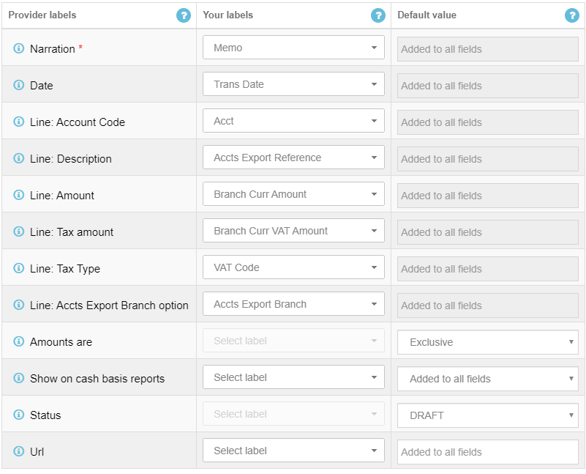
NOTE: For Xero’s Status field customers can choose whether the status of manual journals is set to DRAFT or POSTED at the time of import. The screenshot below will result in the status being set to DRAFT, but this could be set to POSTED instead.

Mapping for Customer Receipts & Refunds file

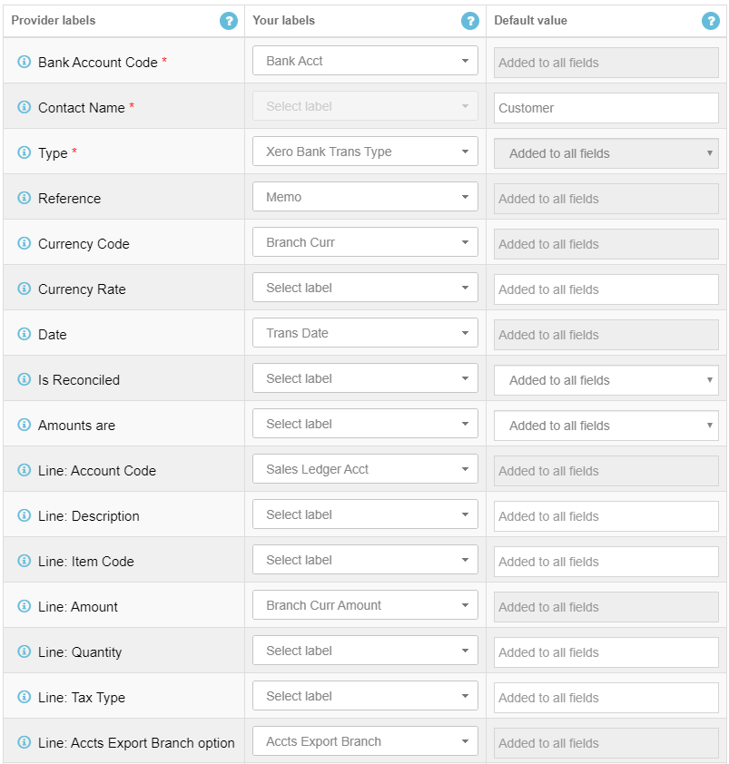
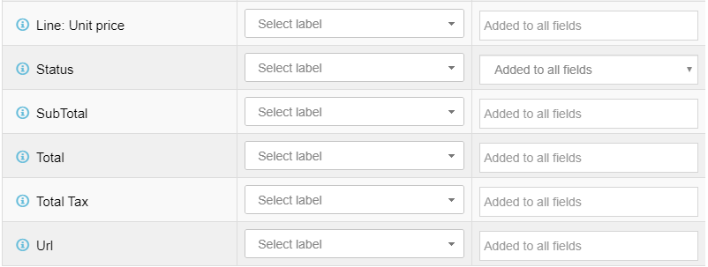

Mapping for Vendor Payments & Refunds file

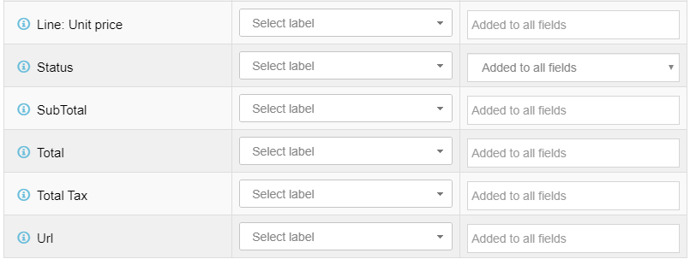
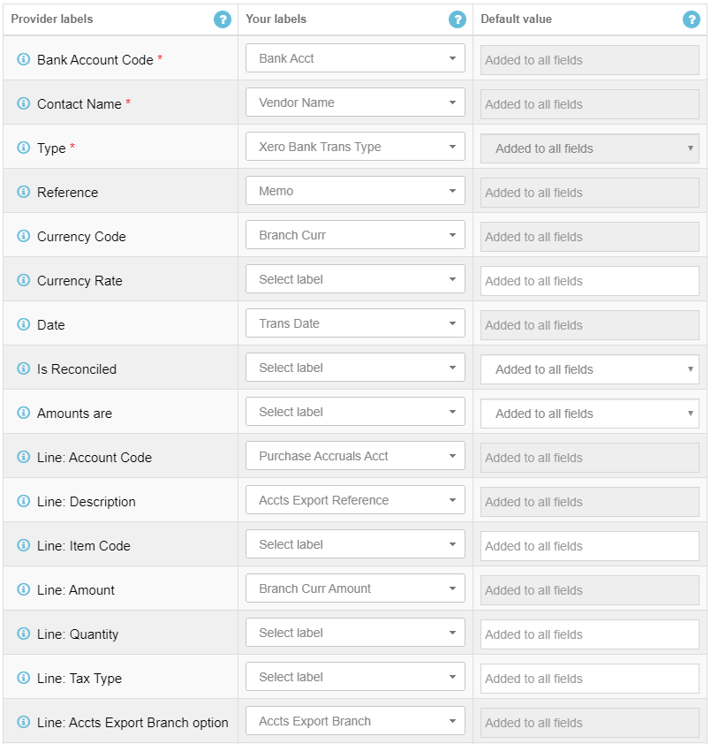

- Clicking on Next or Start Import will save the mapping template
- Saved templates will then appear in the lower left dropdown menu:

The configuration to import the Generic Accounts Export files from the BMM into Xero via Business Importer should now be complete! Going forwards refer to the section below for the summary steps to import your Generic Accounts Export files into Xero.

Xero Import - Summary Steps
- Log into Business Importer
- Select Upload file
- Select the transaction/list type depending on which Generic Accounts Export file type you wish to import:
  - Sales & Cost of Sales file > Manual Journal
  - Customer Receipt & Refunds file > Bank Transaction
  - Vendor Payments & Refunds > Bank Transaction
- Point Business Importer to the relevant Generic Accounts export file
- On the Mapping page select your pre-configured mapping template
- Run the import
- Log into Xero – the data will now be in Xero

Other Information
- The Vendor List file is not required for the Xero import.

Using the Generic Accounts Export Files with Other Accounts Packages
The Generic Accounts Export files could be imported into other accounts packages apart from QBO or Xero. Customers will need to work out which columns of the export files to map to the accounts package fields, using the Generic Accounts Export_Export File Guide spreadsheet for guidance.
Once the mapping templates are created customers should then run tests for each export file to ensure that the mapping is correct.

Appendix

Sample Export Files
Accompanying this guide is a batch of sample generic accounts export files for different booking scenarios. This will allow you to understand how accounting data is represented in the files.
The sample files can be found in the embedded zip file on the front page of this guide.
For all scenarios the BMM’s branch currency is GBP.
Scenario | Notes | Sample File Name (.csv)
Sales & Cost of Sales export file
No VAT, positive totals | Buy 90, Comm 10, Sell 100 | DOLPHIN_SALCOS_MTG_140420201339
No VAT, negative totals | Buy -90, Comm -10, Sell -100 | DOLPHIN_SALCOS_MTG_140420201414
VAT on Commission | Buy 900, Comm 100, Comm VAT 20, Sell 1000 | DOLPHIN_SALCOS_MTG_140420201423
Purchase & Sales VAT | Buy 90, Buy VAT 19, Comm 10, Sell 100, Sell VAT 20 | DOLPHIN_SALCOS_MTG_140420201432
Agency split commission with VAT on split commission | Buy 900, Comm 100, Split Comm 50, Split Comm VAT 10, Sell 1000 | DOLPHIN_SALCOS_MTG_140420201445
Multiple multi-line journals with different accounting dates, etc. |  | DOLPHIN_SALCOS_MTG_140420201552
Customer Receipts & Refunds export file
GBP receipts – cash & cheque | Receipted in different banking branches which are mapped to different bank accounts. | DOLPHIN_RECRFD_MTG_020420201618
GBP receipts – cash & 2 adjustments | Adjustment receipts (& refunds) are itemised, so these appear on two separate lines. Memo column contains more detailed transaction information. | DOLPHIN_RECRFD_MTG_020420201636
GBP receipt & refund | Receipted in different banking branches which are mapped to different bank accounts.  This example illustrates how certain columns are populated for negative rows. | DOLPHIN_RECRFD_MTG_020420201658
USD customer currency receipt | Export file shows transaction amounts in USD (customer currency) & GBP (branch currency) | DOLPHIN_RECRFD_MTG_020420201722
Vendor Payments & Refunds export file
GBP payment | Simple example with one vendor payment row. | DOLPHIN_VENPAY_MTG_080420201535
Multiple payments in different currencies | Payments in GBP branch currency & USD vendor currency.  For USD payment export file shows transaction amounts in both currencies. | DOLPHIN_VENPAY_MTG_080420201559
GBP payment & refund | This example illustrates how certain columns are populated for negative rows. | DOLPHIN_VENPAY_MTG_080420201606

